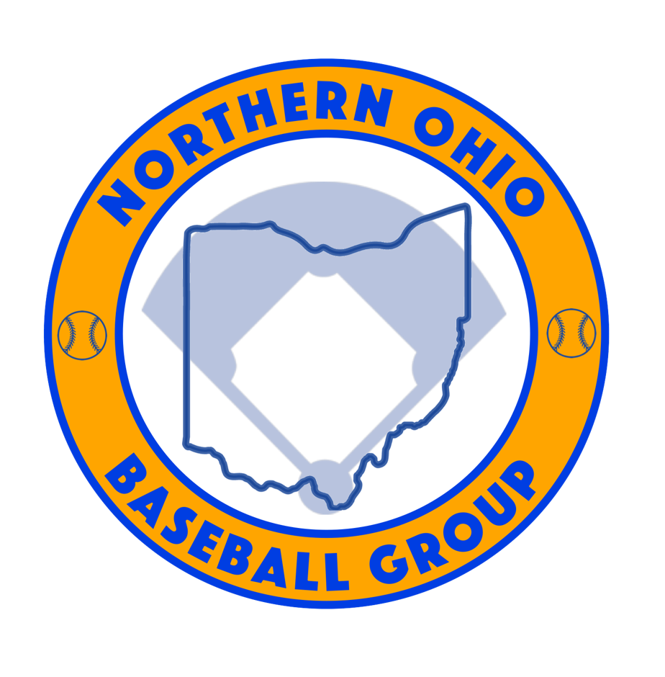 2020 Policy Change
Pre-Paid Gate
- In previous years, all Northern Ohio Baseball Group events charged a $5 gate for all spectators 13 years and older OR a $20 Event Pass.
- Due to the Covid19 Pandemic, the Northern Ohio Baseball Group wants to eliminate as much contact as possible and will be enforcing a Pre-Paid Gate.
- Pre-Paid Gate will be $250 for the full event per team.
Comments
We understand this is typically a Spectator to Event transaction and we believe it should be. We need teams to collect in a fashionable time period. We will require all Gate Fees to be paid the Monday of the event. If not paid, team will be removed from competition.
How to Pay
Please follow the link below
https://checkout.square.site/buy/FQ7FCTX3DYGYRKLJN74HCTZK
All Spectators/Coaches/Players must adhere to the Ohio Covid19 Guidelines
- Please follow the link below to review
https://coronavirus.ohio.gov/static/responsible/Baseball-Softball.pdf
Comments
In order for this event to run, the Northern Ohio Baseball Group submitted a proposal to the local health organizations. This proposal meet the standards that Governor DeWine set. We all have different feelings about said guidelines but this is what we have to do to allow our kids to play. 1st time offenders will be reminded. 2nd time offenders will be asked to leave the complex for the day. 3rd time offenders will be removed from the tournament.
Bathrooms and Concessions
The Northern Ohio Baseball Group does not control any bathrooms or concessions. NOBG rents facilities from Colleges, High Schools, and Private owners. Whatever policy they have in place is their decision and is up to them. We do allow our spectators to bring in their own drinks and food. We highly recommend using any bathroom facilities prior to arriving at a park. We will try to publish before the event what facilities have what amenities open.
Thank you
Phil O’Shea
(419)707-9800

