How to Upload Insurance to PG Site
Step 1: Log in to your PG account and press the little person in the top right of the screen.
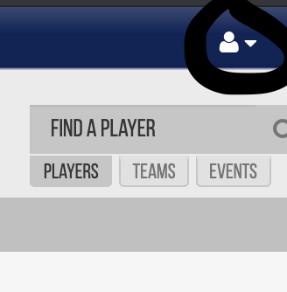
Step 2: Once that is clicked, go to “My Account,” scroll all the way down to the bottom where it says “Teams” Under the event that you are playing in for the weekend, there should be 4 options, click on “Team’s Event Checklist” (For organizations, you will need to upload insurance one time for each one of your teams, until the policy expires)

Step 3: Once you click on “Team’s Event Checklist,” you will then scroll to the bottom of the page, where you should see “Minimum Insurance Requirements”
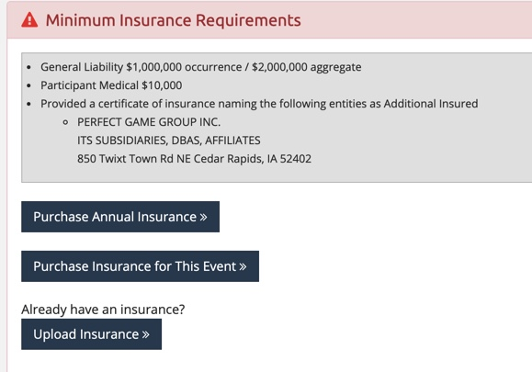

Step 4: Make sure you have Perfect Game as Additionally Insured on your plan. The information below is what you will need to add PG to your policy.
You will need to send a request to your insurance provider to add PG to your policy. This is done at no cost to you, and PG has to be added to your policy in order for the insurance to be approved to your account.

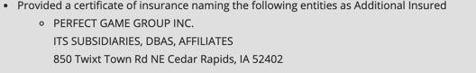

Step 5: You will click on “Upload Insurance”, fill out all of the information about your insurance, and finally, attach a PDF of your insurance at the bottom of the Page.
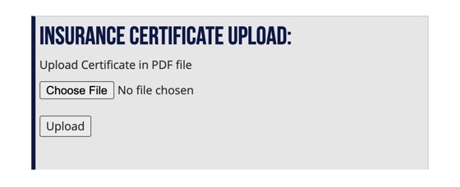

You will need to do this one time, per team, until the insurance expires. Once the insurance expires, you will need to repeat these steps up upload your new policy to the website.

For Insurance Help:
Please call 260-755-7265
OR
Email: perfectgame@americanspecialty.com

